1. **a) Flowchart for the Face tracker:**

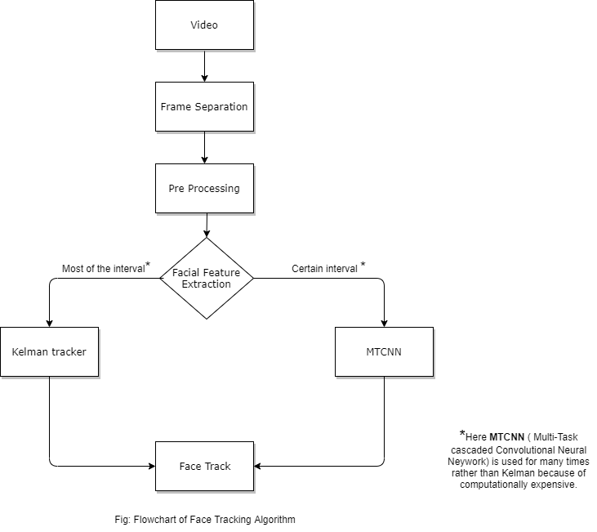

**b) Pseudocode for the kalman tracker:**

1: Initial Estimates for

Xˆ k−1 and Pk−1

2: Time Update

•Project the state Xˆ − k = AXˆ k−1 + BWk

• Project the error covariance P − k = APk−1A T + Q

3: Measurement Update

• Compute Kalman gain Kk = P − k HT HP − k HT +R

• Update estimate with measurement Zk Xˆ k = Xˆ − k +Kk (zk − HXˆ − k )

• Update error covariance Pk = (1 −KkH)P − k

The state equation is Xk = AXk−1 + Bwk (9)

The measurement model is Zk = HXk + vk (10)

1. We cannot say that Euclidian distance is enough for feature matching. Some cases, it is enough and some cases it is not enough. It varies from problem to problem. “**Cosine Similarity**” is better for some problems.
2. We ca n improve Euclidean distance-based matching without another algorithm. We can use the formula- which is upgraded formula of Euclidean distance formula.